1.4 Definitions and Explanation of Some Relevant Terms
1.4.1 Quality
The International Organization for Standardization (ISO) defines quality as “The totality of features and characteristics of a product or service that bear on its ability to satisfy stated and implied needs.” In other words, quality is conformance to specifications or requirements defined by customer. Quality is not binary rather a
continuous structure between good and bad.
Quality management uses quality assurance and control of processes as well as products to achieve more consistent quality. ISO publishes standards that provide guidance on how to ensure consistency and continuous improvement of quality in products or services. For example, ISO 9001:2008 [2] sets out the requirements of a quality management system. Companies or organizations can get certification that a quality management is in place. This ISO standard has been implemented by over one million organizations in over 170 countries [3].
Numerous techniques are available for improving quality. Examples for the methods of quality management and techniques that incorporate and drive quality improvement are ISO 9004:2008, Total Quality Management (TQM), statistical process control, Six Sigma, Quality Function Deployment (QFD), Quality Circle, Taguchi methods, etc.

1.4.2 Reliability
As per IEEE (Institute of Electrical and Electronics Engineers) standards [4], reliability is defined as the ability of a system or component to perform its required functions under stated conditions for a specified period of time. The key lements of the definition are ability, required function, conditions, and specified period of time. Ability is expressed quantitatively with probability. Required function relates to expected performance. Stated conditions usually refer to environmental conditions of operation. Specified period of time is also referred as mission time which provides expected duration of operation. Mathematically, reliability is defined as the probability that the random variable
time to failure (T) is greater or equal to mission time (t), as shown below.
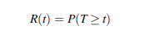

Typical measures of reliability are failure rate/frequency, mean time to failure, mean time between failure, etc. Although reliability provides quantitative measure of performance, one should not look at the absolute values but rather on relative basis. For example, comparison with a target value expected by regulators or comparison among alternative design changes. It is important to understand the difference between quality and reliability. As
mentioned before, quality is conformance to specifications, which is at time t = 0 before we start operation. Reliability can often be termed as projection of quality over time, meeting customer’s expectations over its life time.
1.4.3 Maintainability
BS 4778 defines maintainability as “The ability of an item, under stated conditions of use, to be retained in, or restored to, a state in which it can perform its required functions, when maintenance is performed under stated conditions and using prescribed procedures and resources” [5]. The measure of maintainability is the probability that the maintenance action can be carried out within a stated interval. Corrective maintenance is done after the occurrence of failure. However, in order to reduce the chance of failures and associated inconvenience, maintenance can also be preventive or predictive. Corrective Maintenance The maintenance carried out after fault recognition to put an entity into a state in which it can perform a required function.
Preventive Maintenance
The maintenance carried out at predetermined intervals or according to prescribed criteria and intended to reduce the probability of failure or the degradation of the functioning of an entity.
Predictive Maintenance
Form of preventive maintenance performed continuously or at intervals governed by observed condition to monitor, diagnose or trend a structure, system or components’ condition indicators; results indicate current and future functional ability or the nature of and schedule for planned maintenance. It is also known as condition based maintenance. Typical measures of maintainability are repair rate, mean time to repair, etc. The technical specifications such as surveillance test interval and inspection interval are often determined using the reliability and maintainability studies.
1.4.4 Availability
As introduced by Barlow and Proschan [6], availability is the probability that a product or system is in operation at a specified time. This definition can be termed as instantaneous availability. There are several forms of availability. For example, average availability is defined on an interval of the real line and steady state availability is the limit of instantaneous availability function as time approaches infinity. Availability is same as reliability for a non-repairable system. For a repairable system, it can be returned to service with repair when failure occurs, thus the effect
of failure can be minimized. By allowing repair, reliability does not change but availability changes.
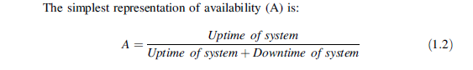

Uptime depends on reliability of the system where as downtime depends on maintainability of the system. Thus availability is function of both reliability and maintainability.
1.4.5 Risk and Safety
Several definitions of risk exist in the literature. The most popular definition of risk is the one proposed by Kaplan and Garrick [7]. They defined risk as function of answers to three questions: “what can go wrong?”; “how likely is it to go wrong?”; “if it does go wrong, what are the consequences?” Quantitatively, risk is defined as a set of triplets as shown in equation:
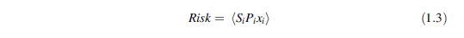

Where ‘i’ is a scenario number, i = 1, 2…N and Si is an accident scenario which has probability of Pi and a consequence of xi. For example, an accident scenario in a chemical plant has a probability of 1e-2 and its associated consequences results in a financial loss of $10,000. Consequences of different scenarios may have similar or
same consequences, which results in probability/frequency of scenario as the vital element. Popular measures of risk for nuclear industry are core damage frequency and large early release frequency. Aven’s definition of risk includes uncertainty as an essential element of risk. As per his definition [8], risk is function of accident scenario (A), consequence (C), and uncertainty (U) about A and C, Risk = (A, C, U).
Risk and safety are related to each other: the higher the risk, the lower the safety. Risk assessment is also referred as safety assessment with practically no difference in engineering applications.
1.4.6 Probabilistic Risk Assessment/Probabilistic
Safety Assessment
Probabilistic risk assessment/probabilistic safety assessment (PRA/PSA) is aimed at evaluating the risks of a system using a probabilistic method. IAEA safety standards [9, 10] define PSA as a comprehensive, structured approach to identifying failure scenarios, constituting a conceptual and a mathematical tool for deriving numericalestimates of risk. PSA/PRA essentially aims at identifying the events and their combination(s) that can lead to severe accidents, assessing the probability of occurrence of each combination and evaluating the consequences. The term PRA
and PSA are interchangeably used. PSA/PRAs are performed for practically all nuclear power plants (NPPs), and
also applied in aerospace, chemical and process industries. In NPPs, it is performed at three levels: Level-1 PSA to estimate core damage frequency, Level-2 PSA to estimate radioactive release frequency, and Level-3 PSA to estimated public health and societal risk.

History
A historical overview of reliability and safety engineering in the form of important milestones is briefly described below. The concept of reliability and safety started relatively later than other engineering branches. As Dr. W.A. Shewart inspired the rise of statistical quality control at Bell labsin 1920s, W. Weibull conceived the Weibull distribution to represent fatigue of materials. Pierce in 1926 introduced the concept ‘the axiom that a chain is
no stronger than its weakest link is one with essential mathematical implications’. In the 1930s, aircraft accidents were recorded in the form of statistical reports by collecting failure data of various aircraft components [11]. Designers and manufacturers made use of this feedback for improvement of future designs. The first risk objective for aircraft safety was defined by Pugsley in 1939. He asked for the accident rate of an aircraft should not exceed 10−5/h. The first predictive reliability models appeared while Wernher von Braun, one of the most famous rocket scientists, was working on the V1 missile in Germany. The rockets were found to be having poor reliability. The team worked based on the principle that a chain is no stronger than its weakest link. But failures were observed with not only the weakest part but also with remaining components. The team later consulted a mathematician, Eric Pernchka, who came up with a concept
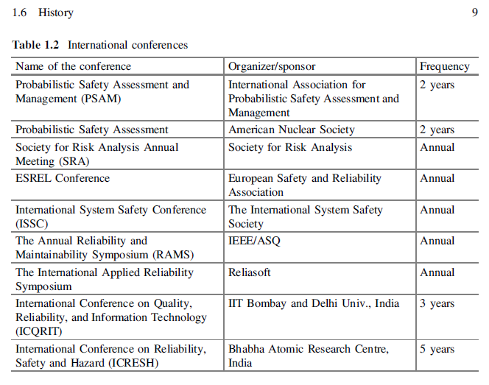

which says ‘if the survival probability of an element is 1/x, survival probability of system of n such similar components will be 1/xn, which forms the basis for the reliability of series system [11]. Subsequently, Wern Von Braun introduced the concept of redundancy to improve the reliability of systems. The concepts of reliability developed slowly until World War II. During the War, over 50 % of the defense equipment was found to be failed state in storage; it was due to electronic system failure and in particular because of vacuum tube failures. The unreliability of vacuum tube acted as a catalyst to the rise of reliability engineering. Reliability was born as a branch of engineering in USA in 1950s. In 1952 the Department of Defense (DOD) and the American electronic industry created the Advisory Group on Reliability of Electronic Equipment (AGREE). AGREE report suggested modularity in design, reliability growth and demonstration tests to improve reliability and also a classical definition of reliability. This study triggered several applications in electronic industry and also spread to aerospace industry. This period witnessed the first conference on ‘quality control and reliability’ and the first journal in the area ‘IEEE Transaction on Reliability’ by the Institute of Electrical and Electronics Engineers. In 1961 H.A. Watson introduced ‘Fault Tree Analysis (FTA)’ concept to evaluate control system of Minuteman I Intercontinental Ballistic Missile (ICBM) launching system at Bell telephone laboratories. The FTA is one of the pillars for safety and risk assessment even today, which is extensively used in aerospace and nuclear industries. The failure mode effect analysis (FMEA) method was also introduced in the early 1960s by aerospace industry. FMEA technique also became popular in automotive industry. Following Apollo 1 disaster in 1967, aerospace industry began to use a systematic approach to evaluate risk called ‘Probabilistic Risk Assessment (PRA)’. In 1960s, specializations of reliability engineering
emerged, for instance structural reliability as a branch was born to investigate structural integrity of buildings, bridges, vessels, pipes, etc. [12]. Distinguished mathematicians Birnbaum, Barlow, Proschan, Esary and Weibull extensively contributed to the development of mathematics of reliability [11].

In the early 1970s, nuclear industry had adapted PRA concepts from aerospace industry, but subsequently PRA methods developed in nuclear industry were adapted by aerospace industry [13]. Undoubtedly the ground breaking study for risk assessment of nuclear power plants is the Reactor Safety Study initiated by US Atomic Energy Commission and led by the pioneer Prof. Rasmuseen. This landmark study resulted in a comprehensive WASH-1400 report [14]. This study investigated a large number of accident scenarios, quantified risk, and identified important risk contributors. Event tree analysis took birth during this study, which is an essential element of today’s PRA/PSAs. Although the study had been criticizedfor underestimating uncertainties, dependencies, and operator actions, three mile island (TMI) accident which took place in USA in 1979 resembled one of the accident scenario identified in WASH-1400. PRA methodology received a major boost after TMI accident. US Nuclear Regulatory Commission made extensive efforts to develop and promote PRA methods. For example, NUREG-1150 [15]
study assessed risk of five US nuclear power plants, which demonstrated the potential PRA applications. Today practically nuclear power plants all over the world perform PRA/PSAs and regulators use PRA/PSAs in the risk informed regulation of plants. Risk assessments have also been performed in other industry sectors, for instance, aeronautical, chemical, power, railways for complying with regulations and also for design improvements. In 1970s, another branch of reliability engineering emerged, software reliability which was concerned about software development, testing and improvement [16]. In 1980s, methods to capture dependencies and to model operator actions were extensively developed. For example, common cause failure models proposed by Fleming [17] and Mosleh [18] and human reliability analysis methods introduced by Swann [19]. Techniques such as Bayesian analysis to update failure models with field date and also use of accelerated life testing to investigate failure causes became popular during this time [20].
Traditionally basic event or component failure models were obtained from statistical analysis of field or life tests data, Bayesian updating, or expert elicitation techniques. To overcome the criticism about uncertainties in such models, 1990s witnessed the rise of physics of failure or mechanist models, especially in electronic, electronic, and mechanical components. This approach used knowledge of degradation process and operating stresses/loads to characterize failure mechanisms. The recent trend is the hybrid methods that combine different types of data
including failure data banks, expert judgment, physical of failures information, and life test data using Bayesian updating technique [20].
Complexity of systems and technological developments is ever increasing. To cope with these challenges, imulation based safety/reliability analysis methods have been receiving increased attention. The availability of high performance computing infrastructure at unprecedented levels helps in such simulations. Integrating deterministic models with probabilistic models are being explored to improve reliability/risk modeling taking advantage of computational power.

